**Law Ting Pong Secondary School**

**Information and Communication Technology**

**School-based Assessment**



Law Chi Hon

S.6T (32)

**Content**

Part 1：Objective

Part 2：Analysis

Part 3：Design, Implementation and Practical Skills

Part 4：Testing & Evaluation

Part 5 – Conclusion & Discussion

**Part 1：Objective**

**Situation and the Facing Problem**

**T**he English levels of Hong Kong students are decreasing, and the problem become serious. Some of the director said the difficult of the HK A-Level exam is decreasing, the question become easier then 10 years ago but the result of the HK student had not been improved.

**T**he situation become worse after Hong Kong change to use Chinese for teaching, the students have less time to use English and cause their English level decreasing.

**T**eachers, parents and the government are caring about the problem because it will affect the future society of Hong Kong. The English level of Hong Kong students decrease will affect the image of Hong Kong.

**T**he main problem to the Hong Kong students was they are lack of vocabulary, their vocabulary is too poor that not enough to use. Apart from that, they also have the spelling mistake; they cannot spell the word correctly so that the marks will be deducted in the opening exam.

**T**o solve the problem, some helpful education software is needed. Nevertheless, the market does not have the enough or proper software or hardware for helping the students to train them to have a better memory of the vocabulary and learn more vocabulary to improve English.

**T**o face the problem, an English language-learning center would like to provide an information system for children to play English vocabulary games, which improve their English vocabulary.

**Purpose**

**F**or this serious situation, a program for improve the student’s English vocabulary is needed. English vocabulary game can help to solve the situation. Game is the best thing to contact the students to play, and they can learn though playing. A good English vocabulary game can help the students learn more vocabulary and improve their memory. Also people can use the program improve the students’ thinking skills, have fun in learning.

**Target users**

**G**ame is an activity can suit for all people; the English vocabulary game is used for learning, so the game should suit for more people. So I targeted to the people who are in kindergarten. By some of the director said, people can absorb most of base knowledge when we are in kindergarten. For better English, base is the most important thing; the game was set for the kindergarten can help them have a better Basic English.

**Features**

**T**he system is a game, which can let the player learn vocabulary through playing the game. Also it is the online game, which means it can play with other player though the Internet; the player can have fun in learning. The game will have the ranking; the player can check their ranking in the world. Moreover, the game is not only including one play but more than that, that they want and every play has different level for user to select, so the player can choice the play and the level by their English level.

**Strength**

**T**he game have the login system, every player can have their own account after they have registered. The game is using the checkpoint style; the player can play by a way “go through a critical test”. The player can try the next level after they have finished the level. Apart from that, the player can **get the points** though playing the game; the points will be used for ranking the users’ result and they can check their **ranking** in the world. Also the points can use for **buying** the virtual items or the discount coupon in the store inside the game. Expect that, the game will set up an **Internet competition**, let the player can play the game with other countries’ player to have an international communication. Moreover, the game **inbuilt the dictionary**, the player can play check the words when they are needed.

**Expected Outcome**

**Hong Kong Student**

The Hong Kong students’ English level will increase; they can remember lots of useful vocabulary and will not spell wrongly.

**Hong Kong Teacher**

The teachers no need to worry about is the students’ vocabulary enough and has more time to train them in other way.

**Hong Kong Government**

The Hong Kong students’ English level increase, the better academic result they can get then Hong Kong’s international status will be increased.

**Programmer**

The programmer gets a great success though the game and he have deeper understands about the program.

**Parents**

No need to worry about the English result of the students, they can also play with the students and improve English though the game.

**English Language Learning Centre**

They will accept and do the promotion the game, the game will heat, many people love to play, and the center can earn lots of money though selling the game.

**Part 2：Analysis**

**Details of the Current Situation**

**N**owadays, the English levels of Hong Kong students are keeping on decreasing; some of the research the marks of English in A Level Exam in the pasting 10 years are decreasing. In the past English is the highest marks subject than others but now it becomes lowest. Parents, teachers and government are also worry about that. The situation becomes a serious problem nowadays.

**T**he main reason of the students’ English level drop is they cannot remember the spelling of English vocabulary they do not know many vocabulary.

**M**ore important is they do not have the motion to study English, and then the students’ English cannot be improved for a long time.

**A**lso, the student in Hong Kong do not have much time to use English to communicate with others, they do not have enough chance to practice.

**T**o solve this situation, lots of English vocabulary games were made. Unfortunately, most of the English vocabulary games are not user-friendly, most of the English vocabulary games are board games or just the Internet games, which cannot play every time every place and the user do not know how to play the game. Also the model of these English vocabulary games is old fashion; the users will easily feel bored to the game. These factors block the enthusiastic of the students to improve English.

**The Sub-problems that have to be solved**

**Do not know how to play**

Nowadays, the player was lazy; they do not want to try how to play the game. Therefore, instruction is a must of a game; the user may not understand how to play the game so before playing the game. The player is very relying on the instruction with the game.

**Solution 1 – Make a booklet**

By making a booklet with detail rule of the game, the player can read the booklet when they do not know how to play.

**Strength**

This solution can let the player understand more about the game in any time any place.

**Weakness**

Nevertheless, reading a booklet is boring and slow to know how to play.

**Solution 2 – Guidance system**

When the game is start, the guidance system will run and led the player was first led by the system to know how to play the game, the game will show the rule step by step.

**Strength**

This solution can let the player understand more about the game and easily know how to play.

**Weakness**

Nevertheless, lead the player to play step by step it hard to do.

**Choice of solution**

By comparing strength and weakness, finally I choose to use solution 2. Although solution 2 needs to spend lots of time to do, it can help the player easier to get in the game.

**No active to play**

The students in Hong Kong do not have enthused to learn English. English is the weakness of the student. The student to face the English may not accept the game.

**Solution 1 – New play**

Play with new way. The new things can always attract people to try; it is same as new game.

**Strength**

If the game is totally new, the student may be more active to play.

**Weakness**

Nevertheless, it may needs lots of time to build up a new and funny game.

**Solution 2 – Money**

Play for money. Player can earn money though playing the game.

**Strength**

Money is nearly the most attractive thing in the world, if playing the game can earn money, it may attract more student to play.

**Weakness**

Nevertheless, it needs lots of money and the purpose of the student to play will be changed, and it may affect their understanding on learning.

**Choice of solution**

By comparing strength and weakness, finally I choose to use solution 1. Firstly, the new play can give the positive effect to the student to be more enthusiastic to face the English, but money only attract them to earn money and not studying, it does not have help to solve the problem. Secondly, earn money though playing the game will give them some misunderstand about the money; it must no be happen in the education software.

**Less Communication**

Only a game is not enough, playing individually will feel lonely. The user may have less communication with others and become lonelier.

**Solution – Set up International Communication System**

The game can connect to the Internet and have the competition to other countries’ users and have the communication with them.

**Strength**

The users can have more fun though having the competition with others and the user may make friends with his competitor. Apart from that, the user can have the group competition; the user can group together and have competition with other group, increase the interest of the game.

**Weakness**

The International Communication system needs to take lots of time to finish. Also the system will take lots of space of the game and low down the running.

**Choice of solution**

Although the international communication system will give some negative effect to the game, it can increase the communication with other countries’ user; the user can have the practice with other user to have better English.

**Cannot Satisfied Everyone**

Someone’s English may good someone may bad, the English level of everyone is different, just a game may not satisfy all the users.

**Solution 1 – Set Up Different Level**

The English level of everyone is different; the game will set up different level for the user select the level match with them. Then the game can satisfied for different people. Also the user can challenge to the different level to define the English level of the user.

**Strength**

The different level can let the game satisfied with every user. Also it can help the user to measure their English level and easily find out their improvement.

**Weakness**

It needs to take more time to build the different level and make sure the levels are enough to satisfy every user.

**Solution 2 – Low the level of the Game**

When the game is easier to play, the more people can play the game; every user can play the game easily.

**Strength**

The high English level student can play the game and also the low English level student can play the game as well.

**Weakness**

The high English level student may learn nothing though playing the game.

**Choice of solution**

By comparing strength and weakness, finally I choose to use solution 1. It is because solution 1 has more strength and every user can learn though playing the game.

**Easy to get bored**

People are easy to get tired with it, only the game may attract the user play a period of time only, it cannot help them for longer.

**Solution – Set Up more different game in the problem**

The program includes more than one game, then the user can have a choice on it then the users may not easily to feel bored to all the games.

**Strength**

The player can try more than one play in a game, and harder to tired with the game

**Weakness**

More different game takes more space and more time to finish the game.

**Choice of solution**

Although it is difficult to finish, it is more helpful for the user to improve their English.

**Possible IT skills**

**Platform**

**Windows**

Windows system is the most popular system in the world; most of the companies, schools, and the government will choose to use the windows system. Nowadays “Windows” was develop to “Windows 7” in 2008,and the first “Windows” is “Windows 1.01” which is sold in 1985, it means it had about 30 years’ history. According to the some research, about 90% individual users are using the “Windows”. On the market, most of the computer was installed the “Windows”, if the consumers want to install other system, they must remove “Windows” first so many people will choose to get use to “Windows”.

**Mac OS**

“Mac OS” was the system developed by Apple Inc., the most famous things of Apple Inc. is the logo of them was a bitten apple. Most of the designer will use this system because the color show on the computer is sharp and colorful. Also the program for edit the picture is very useful and user-friendly. Nowadays the famous phone “iPhone” is one of the products of Apple Inc., it can show the “Mac OS” is safety and good to use.

**Android**

“Android”, developed by Google, is free and open for other to use, it can contain most of the characteristic of “Windows”, which can run the program wrote for “Windows”. Because “Android” is free of charge, lots of mobile phone company use to be the OS.

**Reasons of using certain of IT skills**

Lots of software and hardware’s drivers are written for “Windows”, and “Windows” is the most popular OS for people use. The game is designed for more people to play so I will choose “Windows” to be the platform of the program

**Program Language**

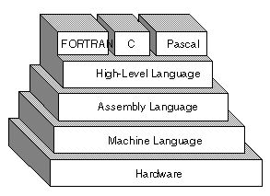**Low Level Programming Language**

**L**ow-level programming language, the original programming language, it includes 1st Generation Language and 2nd Generation Language. The programming language will classified, into low level is because it is hard to understand and the language is very close to the machine code, so low level programming language is not popular anymore.

**B**ut it have a feature that is not need or quickly transform the language into the machine code and can be executed by the CPU at the first time so the operational efficiency is better than the high level programming language.

**1st Generation Language**

**T**he first programming language, which is written by the machine code, was used in 1940. At that time, the computer can only store the data by the binary system, made by the long strings of binary codes, consists “0” and “1” only, for example “1101010100010”. Using 1GLs to write the program, the program can execute the data at once because it had skipped the step of translator.

**N**evertheless, it is difficult to learn or write also it is machine dependent, that the program written by 1GLs cannot execute the data in other computer or bring the data outside the computer. Moreover, using machine code will make the program become lengthy and the programmer need to use more time to write.

**2nd Generation Language**

**I**t is also known as “Assembly language”. It is not using the machine code anymore; it will use the abbreviation known as mnemonics to write. The mnemonics more close to English that can easier to understand or write. Also the mnemonics can help to clear the instructions of the program for classified the use of the program.

**N**evertheless, the 2GLs needs to use the translator to transform it into machine code which need more time to execute than machine code. Also the problem of lengthy, machine dependent and no portable still not solved.

**High Level Programming Language**

**I**t replaces the low level programming language, become the most popular programming language. It is more English-like and closer to human language, which is easier to learn and write.

**N**evertheless, because of the language changed, it must translate to machine code for the computer read and execute, it will take more time to execute the program.

**3rd Generation Language**

**I**t same to 2GLs but better, it is closer to human language and more English-like. Also the 3GLs are not lengthy, which the instructions become clearer than 2GLs that can focus on solving the target problem and easier to debug. Also 3GLs are machine independency that become more portable and can be execute in other platform with little or no change.

**N**evertheless, the language is not close to machine code than 2GL, it need translator for helping to control the CPU in executing the program.

**4th Generation Programming Language**

4GL followed 3GL in increasing trend towards problem-oriented and abstraction. In 4GL, it is more user-friendly that fewer steps is needed to code for solving the problem, the less number of lines of codes of a program, the less time and cost of convert the language.

**5th Generation Programming Language**

It is used in the field of AI, where the program can design the solution to solve the problem itself. The programmer no need to design the algorithm of the program but only need to give out the problems needed to solve.

**Reasons of using certain of IT skills**

By comparing the high and low level programming language, I decide to use high level programming language because it is more English-like and closer to human language that can code the program easier. And I will choose 3rd Generation language to code the program because 3GL is not lengthy, had a clear instruction, machine independency and it is the closest to the machine code in the high level language which can decrease the time of convert the code.

**Program language in 3GL**

**BASIC**

It is a kind of programming language designed for the primary user to use. It is easy to use and no needs to compile or link to execute, it can also create an EXE file for execute the program.

**Pascal**

It is a programming language to help and teach the student to understand the structure of a program, most of the student use Pascal to be the basic language of ICT to know more. It can also use to study in the field of PC Game and Embedded system. The compiler of Pascal is quick and efficiency that no needs take a long time for execute the program.

**Java**

It can write a cross-platform program, which can execute in every system’s computer. Also it can write a program connect to other computer though Internet. It is a kind of Internet coding language; it is close to “C++” but have more improvement.

**C++**

It is an extensive programming language; it can support more than one type of programming language. It is the plus of “C”, but it is different with “C” that can separate into two different languages. “C++” is common but it is also one of the most difficult programming languages.

**Reasons of using certain of IT skills**

In such program language, I will choose “Pascal” to write the program. It is easy to use, have the extensive use and no needs take a long time for execute the program.

**Software development system**

**Turbo Pascal**

It includes a compiler and IDE for the Pascal. There are three old versions are free and the other was expensive.

**Free Pascal**

It is free and open source and Objective Pascal compiler. It supports many other Pascal compilers.

http://img.giveawayoftheday.com/icons/png/32/488/488621.png**Dev-Pascal (Dev-C++)**

Dev-Pascal is free and in IDE to write with Pascal language, it uses the Free Pascal to be the writing and testing system. It is using the General Public License.

**Reasons of using certain of IT skills**

In such software development system, I will choose “Dev-Pascal” to write the program. It is because the system is free to use, have the IDE and using the General Public License.

**Interface**

**Command Line Interface**

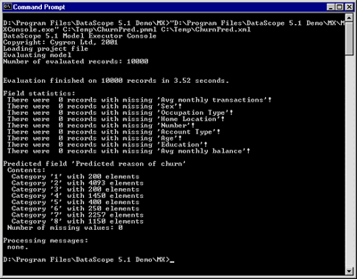It is known as “CLI” or “CUI”. It is the most popular interface before graphical user interface, normally it do not support the mouse, the user only need to use the key board to enter the instruction, then the computer will follow the instruction and execute. There are only word will be placed on the monitor and not picture. But it can save the space of computer because it does not take a large memory. When the user can totally remember all the instruction, the user can operate the computer faster than the “GUI”, that’s why the “GUI” still maintains the interface “CLI”.

**Graphical User Interface**

It is known as “GUI”. It is using the picture to replace the instruction to operate the computer; it is more popular because it is more beautiful and easier to accept it is easy to use. Also it is easier to learn how to use and no code is needed to remember. It is more interest for watching the picture than watching the word only. Nevertheless, it need more time to calculate the color on the monitor and take the space of the computer.

**Reasons of using certain of IT skills**

For the interface, I will choose “Command line interface”. CLI do not take lots of space, response quickly and can be execute in all computers.

**Part 3：Design, Implementation and Practical Skills**

**Layout of the system**

First, the user will face a page, which welcomes them use the program, as the follow:

**WELCOME!**

Then the user will face a page which asks them create a new account or not, as follow:

Create a new account?

If the answer is “Yes”, then it will turn to a new page and ask for the information, then the program will give the ID and Password to the user, as follow:

Name?

Sex?

ID:sX

Password:123456

Then it will turn to the login page (If the answer is “No”, will turn to login page as well), the user needs to input their ID and Password:

ID?

Password?

If the user input the wrong ID or Password, the program will wrong the user and let the user re-input again, until input the correct answer, as follow:

Enter the wrong ID or Password!!

Login again!!

ID?

Password?

After input the correct ID and Password, the user can select the function that they want to use:

Welcome, XXXXX

Select the function

1. Game
2. Profile
3. Ranking
4. Shop
5. Save
6. Exit

If the user selects the function 1, then he will go to a page for choosing the way to play, the user can select to play from the beginning or from the selected level or play with others, as follow:

Select the function:

1. Start from beginning
2. Select level
3. Competition
4. Exit

If the user chooses function 1, then the user will play from level 1, as follow:

Level 1:

Question

Answer:_____

If the user chooses function 2, then the user can select the level they want, as follow:

Which Level do you want?

Level 1

Level 2

If the user chooses function 3 then the program will give an enemy for the user, and have the competition, the one who get the higher points will be the winner, as the follow:

The fighter is XXX

Let’s start!

Level1

XX

XX

XX

If the user chooses function 4 then the program will ask him whether save the data or not, if the user choose “N”, the data may lose, as the follow:

SAVE or NOT? (Y/N)

Whatever the choice is, it will back to the main page, as follow:

Welcome, XXXXX

Select the function

1. Game
2. Profile
3. Ranking
4. Shop
5. Save
6. Exit

Then if the user chooses function 2, it will show the information of the user, as follow:

ID:XX

Name:XXXX

Sex:X

Points:XX

Press “Enter” to back to the main page, as follow:

Welcome, XXXXX

Select the function

1. Game
2. Profile
3. Ranking
4. Shop
5. Save
6. Exit

If the user chooses function 3, it will show the ranking of every user, as follow:

XX XXXX X XX

XXX XXXX X XX

XXXX XXXX X XX

If the user chooses function 4, it will go to a page for user to buy things, as follow:

1. XXX

2. XXX

3. XXX

4. XXX

If the user chooses function 5, it will save the data, as follow:

SAVED

If the user chooses function 6, it will exit the program.

**Input/output data format**



ID Password Name Sex Points

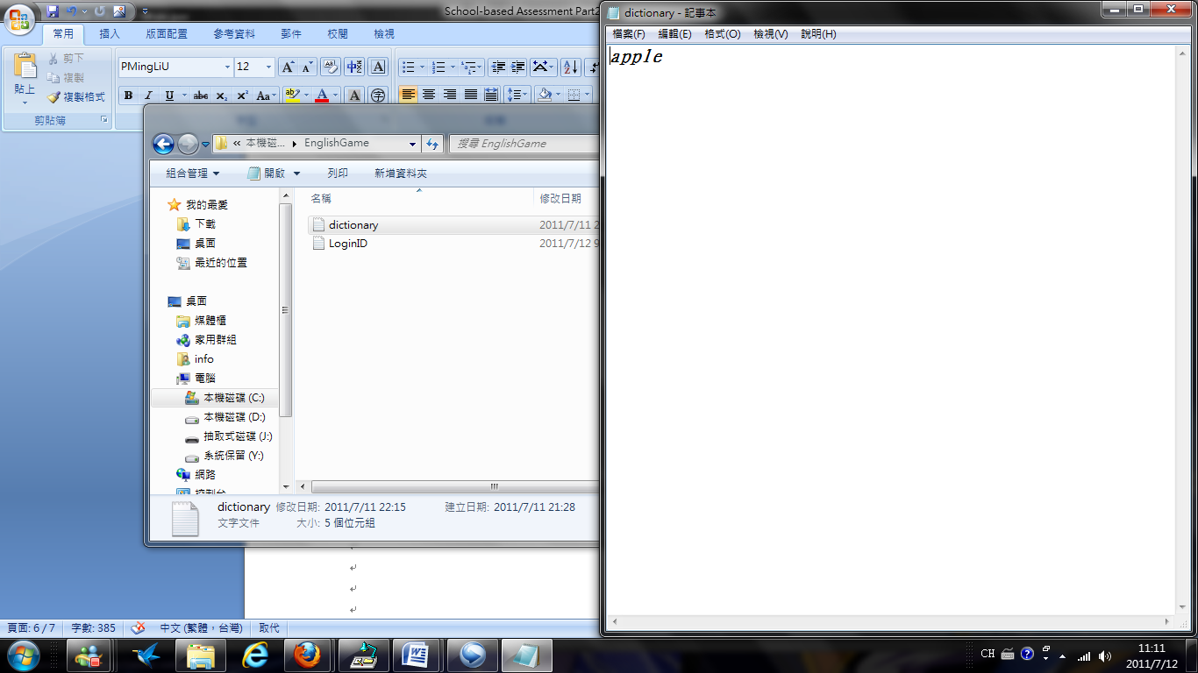

Word

**Special features**

**T**he game can play by **competition**; the user can have the game the computer, and comparing the points user get in rounds with computer’s, to decide the champion. It can remind the heart inside the user, to have more enthusiastic to play the game.

**A**lso, the user can get the points though playing the game, the points can use in **buying things**, this features can makes the user have more meaning on playing the games, the user can earn the properties and the knowledge at the same time, it must give them power to play the game.

**A**part from that, the game will **remind the user** lots of things for example remind the user that he input the incorrect type or the over limit input. Especially the remind for the user to save the record, it will remind the user twice after the user change something, it can help the user not because forget to save record and loss the data.

**M**oreover, the game will start with an **animation**, although it takes some times to load, but it was interesting and most of the game cannot do it.

**A**fter that, the game can let the user edit their profile for example their password and even the name and the sex, which means the user can give the account to others and it can totally belongs to that person.

**F**inally, the game can let the user change the font color for 7 colors! It can make the interface more difference and can match the user. The change will be save in the record so the user no needs to change the color again and again.

**Algorithm**

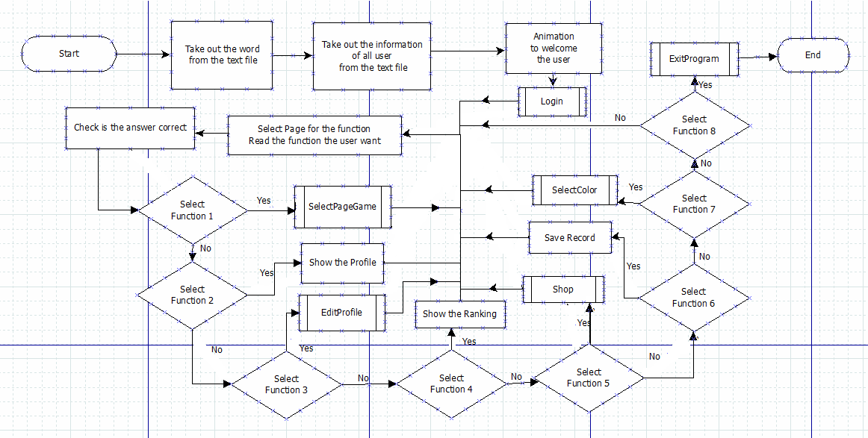**Main Body**

**Procedure**

**Login**

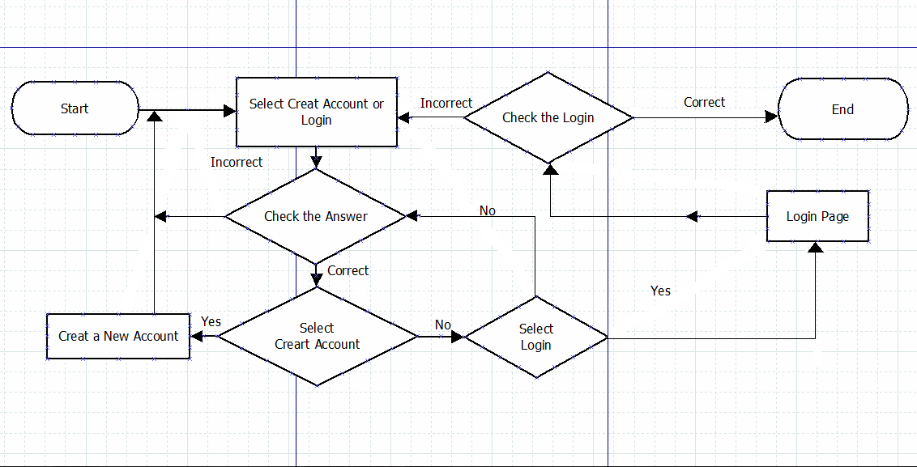

**SelectPageGame**

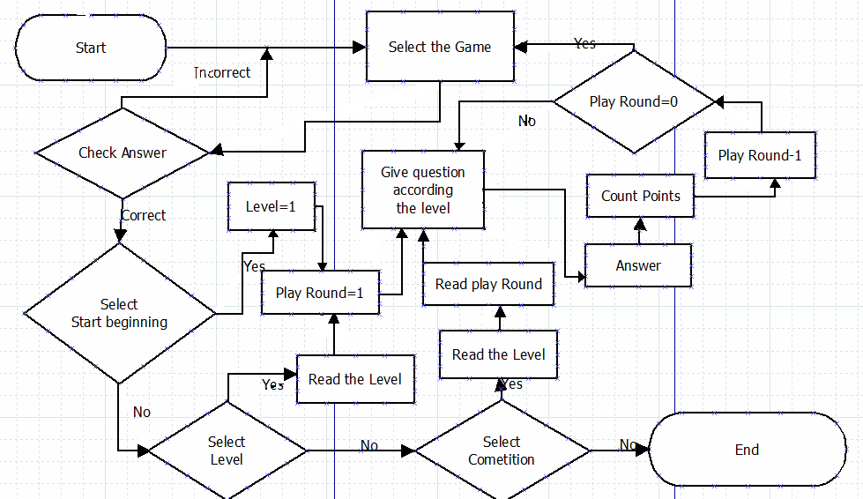

**EditProfile**

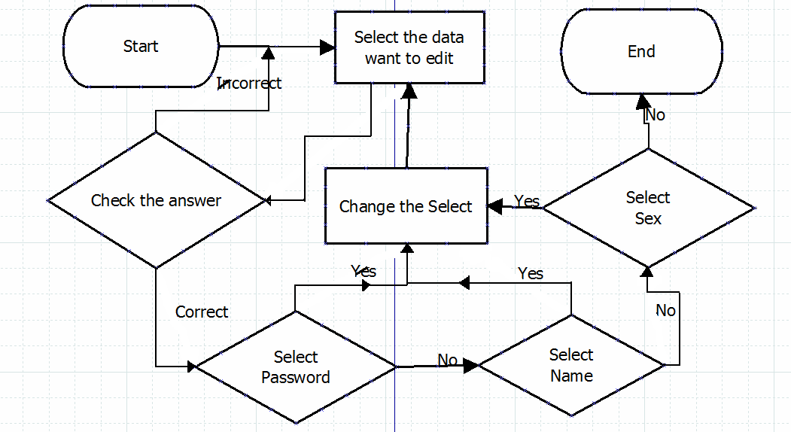

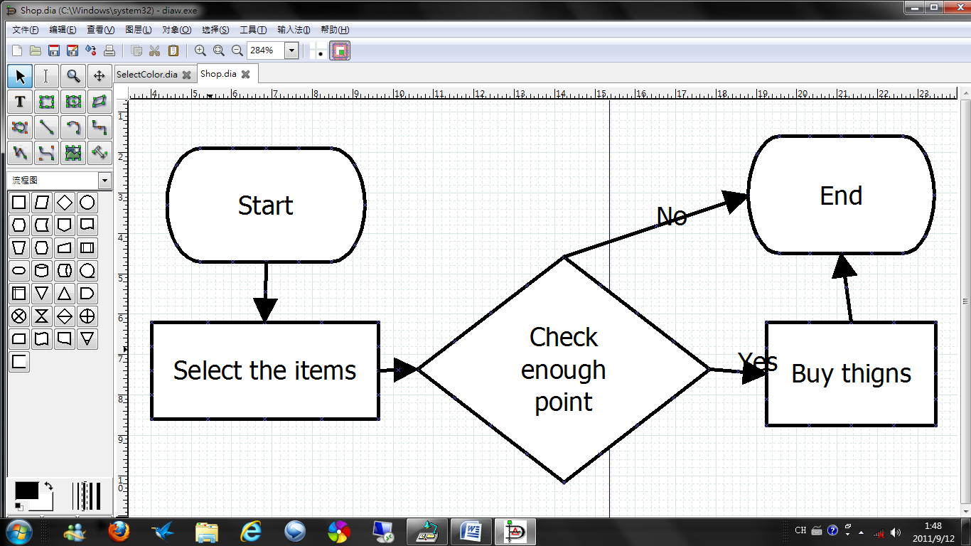**Shop**

**SelectColor**

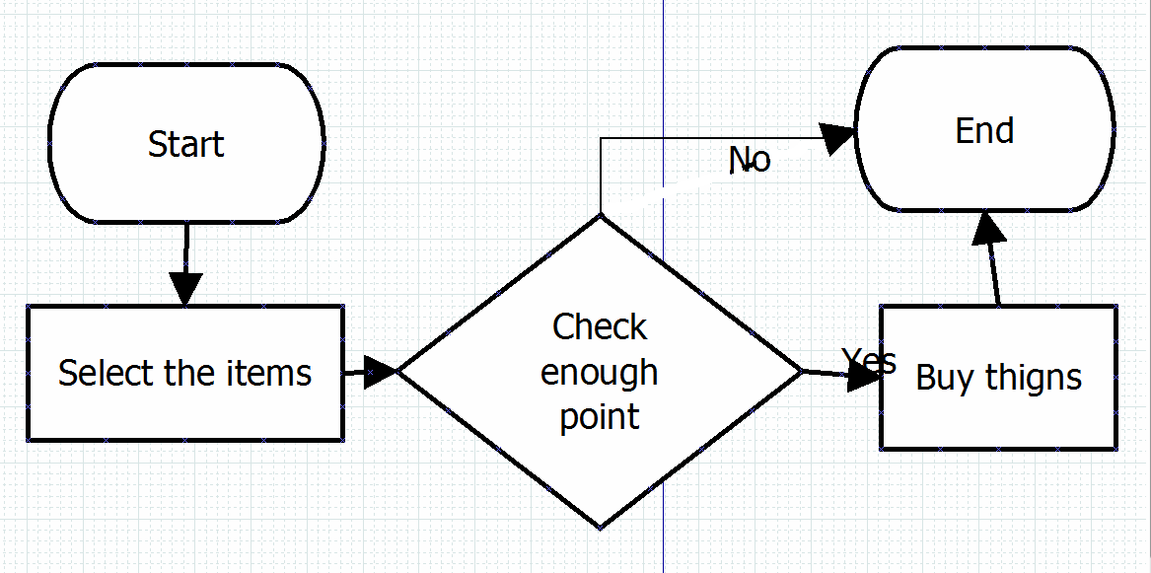**ExitProgram**

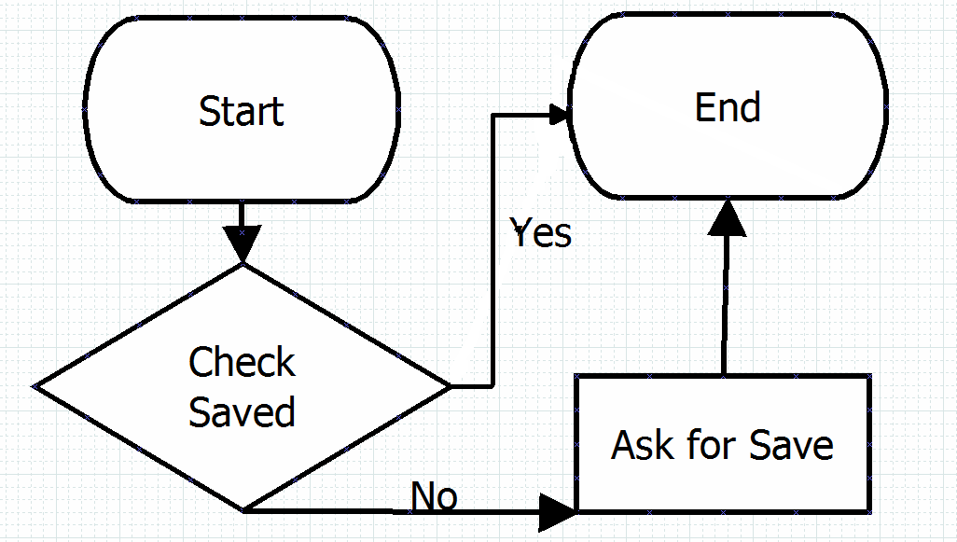

**Installation guide**

**B**efore you start the program, please first create a folder called “**EnglishGame**” and put it into the **C** driver.

**A**fter that, please put the text file called “**dictionary.txt**” and “**LoginID.txt**” into the “**EnglishGame**”. Then you may start the program, ‘**SimHang.exe**’.

**User guide**

1. **T**he welcome page, press enter to continue

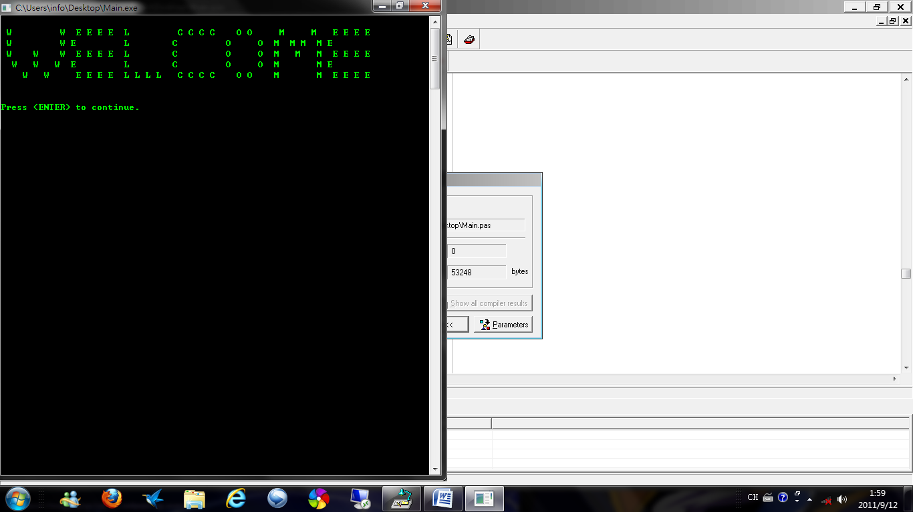

1. **T**hen ask old user or new user

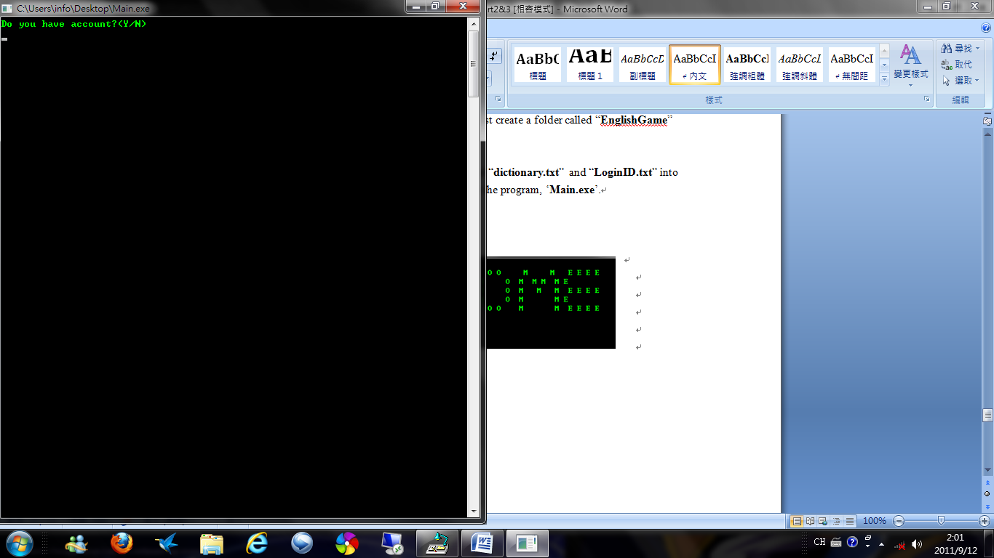

**If you input the things without ‘Y’ or ‘N’, it will warn you.**

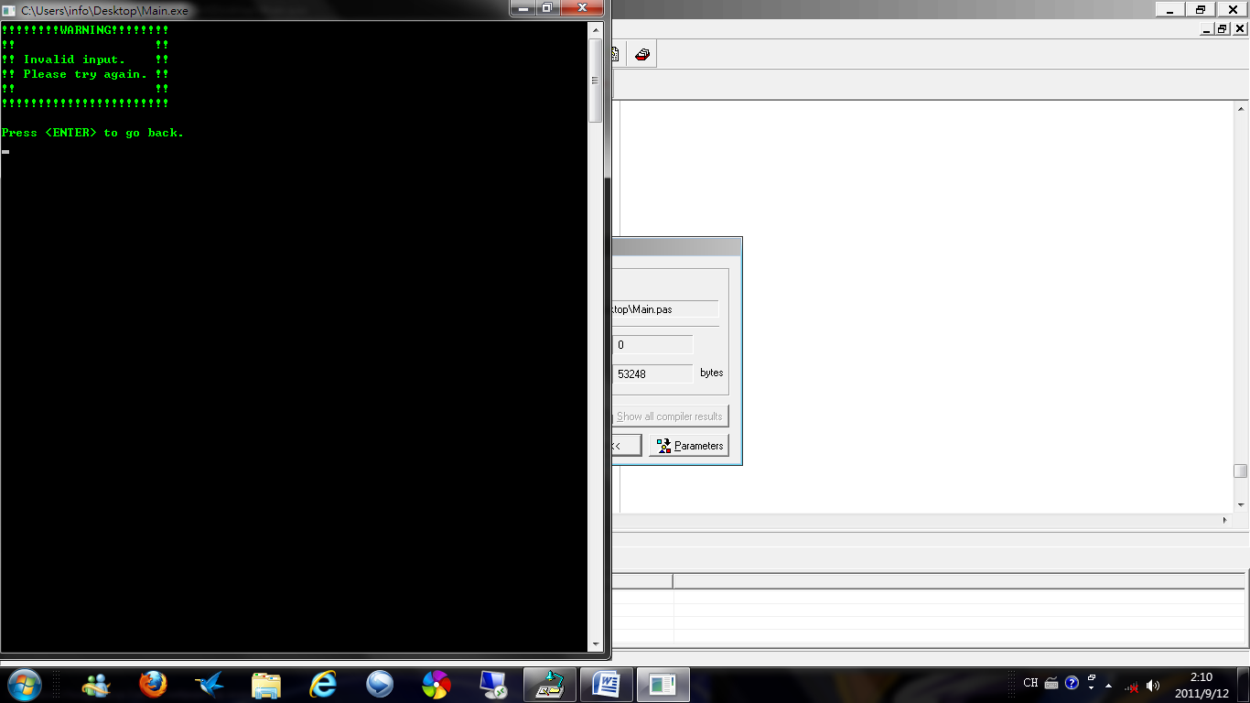

1. **I**f you are a **new user**, press ‘N’ to create a new account

**(If you already got an account, please go to step 8)**

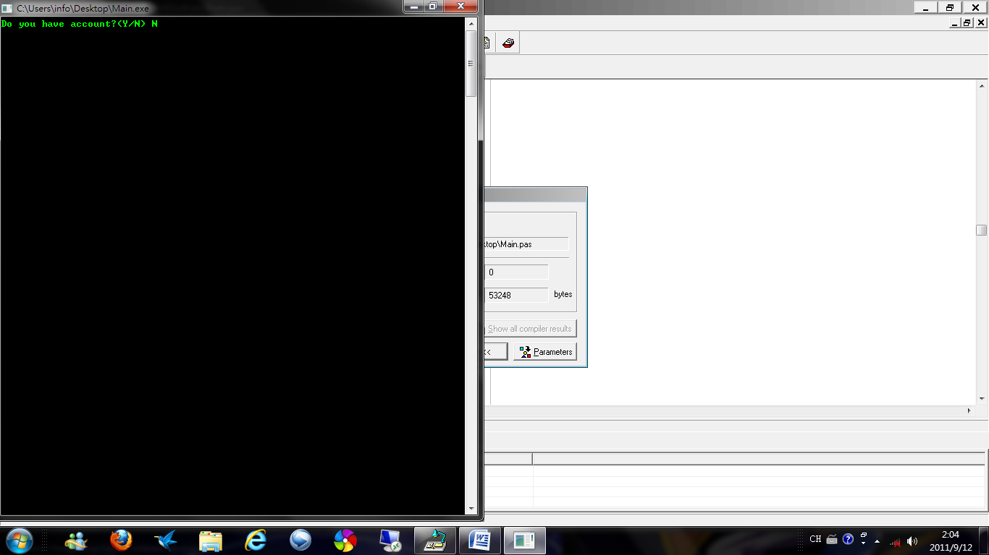

1. **T**hen it will help to go to new page to create your own account

**F**irst, it will ask you the ID that you want **(The ID is used for Login)**

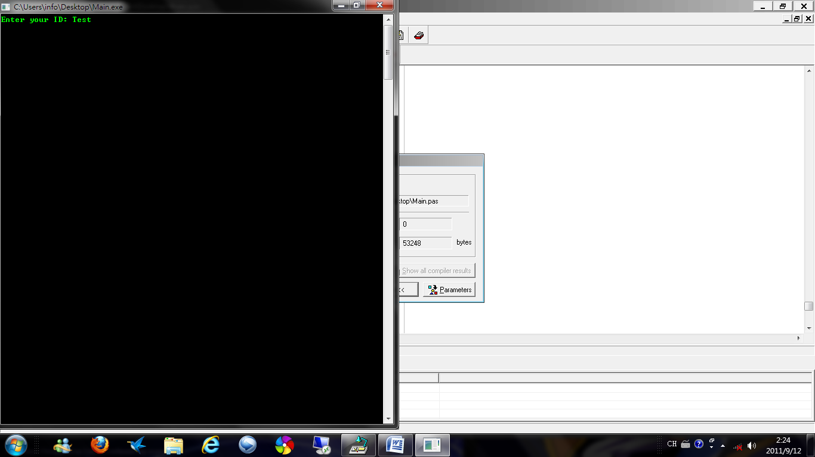

**If the ID had been used, it will warn you.**



1. **A**fter that, ask for password



**Remember, both inputs must be the same, otherwise it will warn you**

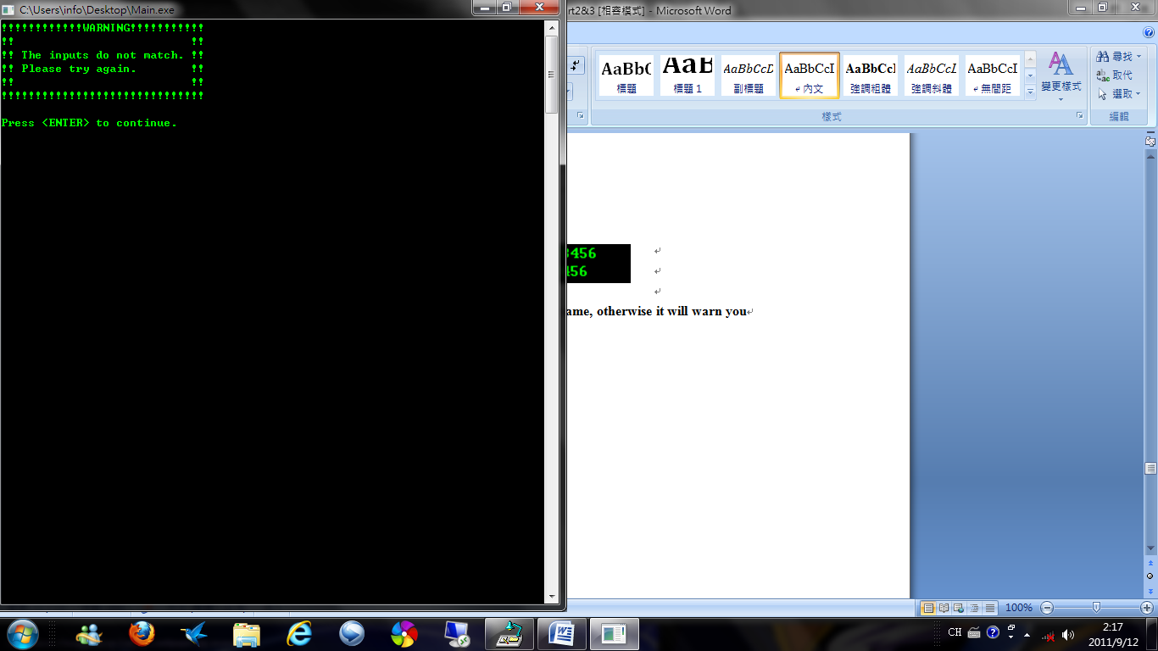

1. **T**hen ask for name

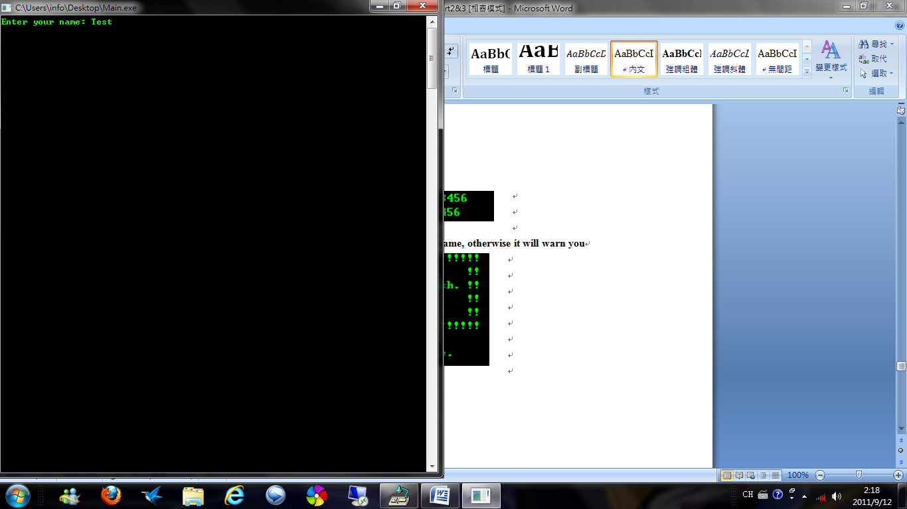

**A**nd the sex

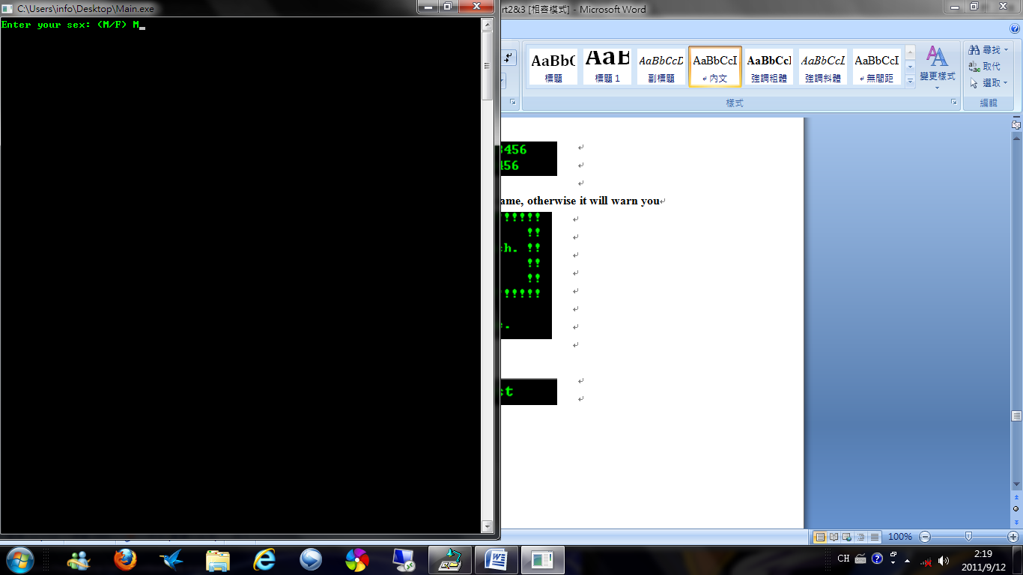

**If you input the sex without ‘M’ or ‘F’, it will warn you.**



1. **A**fter input all information, it will show you the Profile

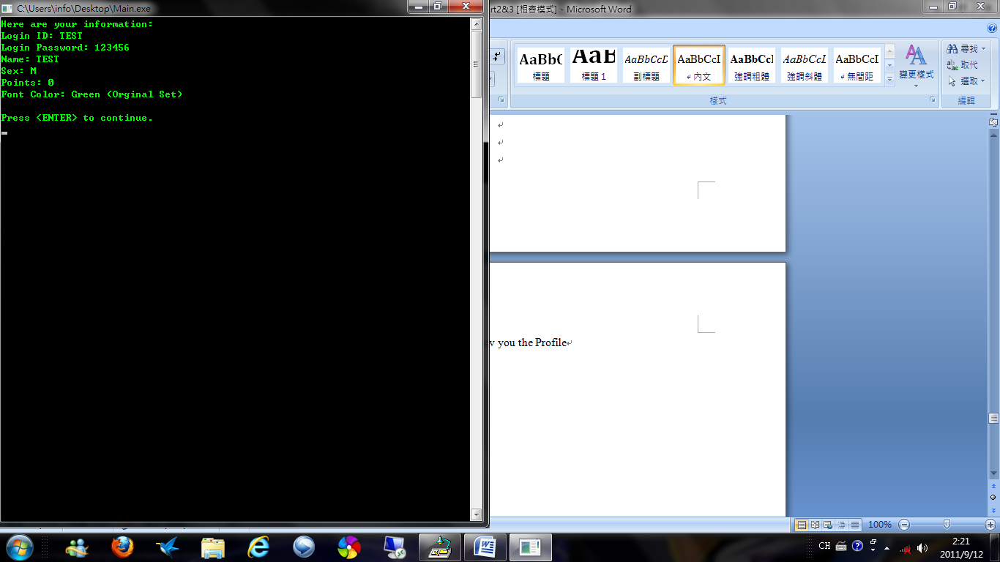

1. **J**ust input the ID and Password

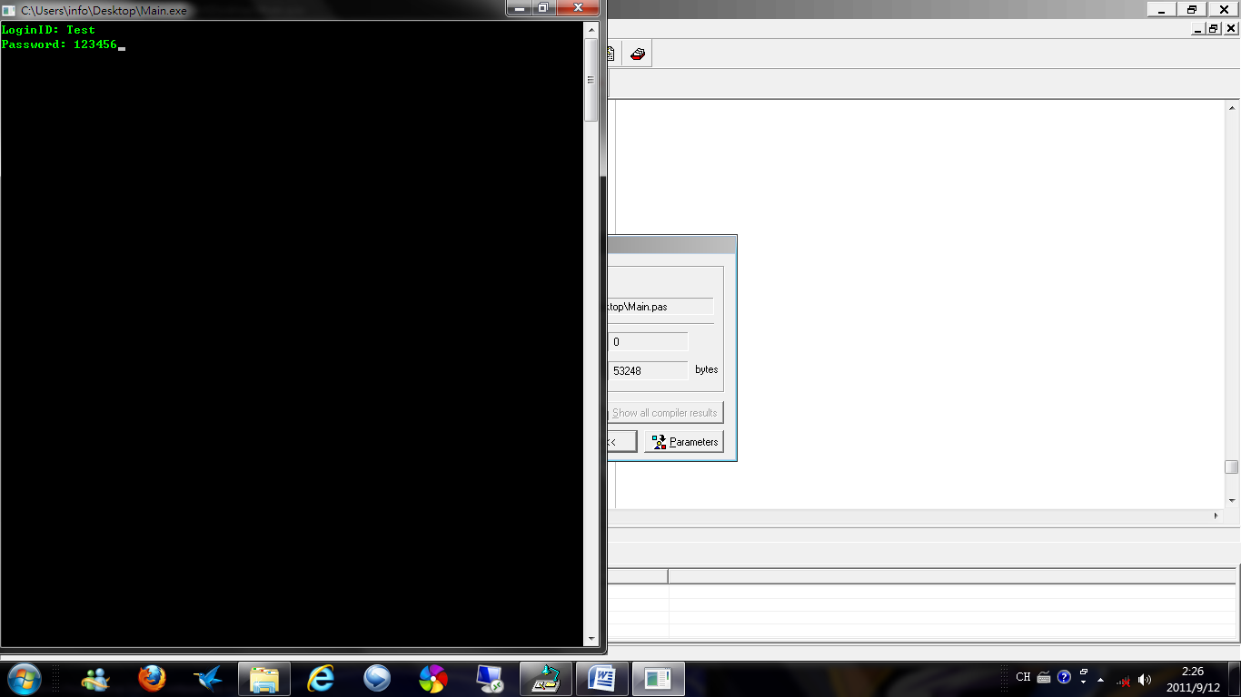

**If ID or Password was wrong, it will warn you and back to Step 2**



**If correct, it will welcome you**



1. **T**hen it will show the select page

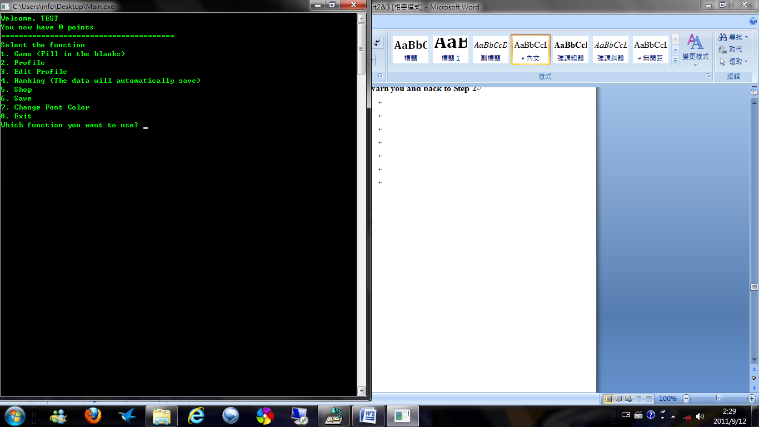

**T**o play game, press ‘1’

1. **T**o ‘Game’, you will see the rules of the game first

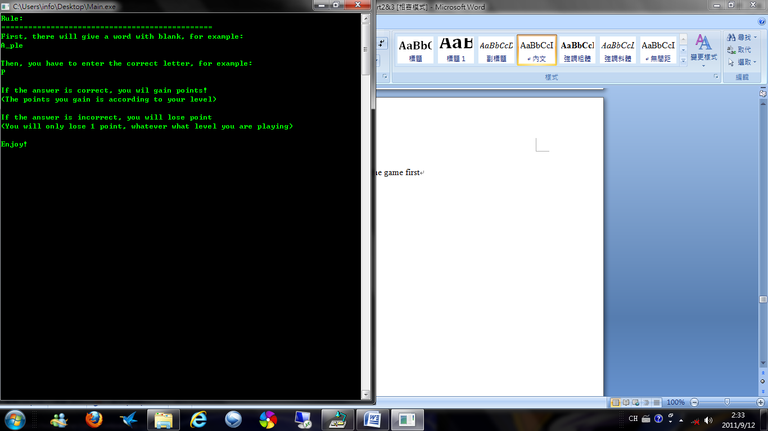

**T**hen, you can select the game you want

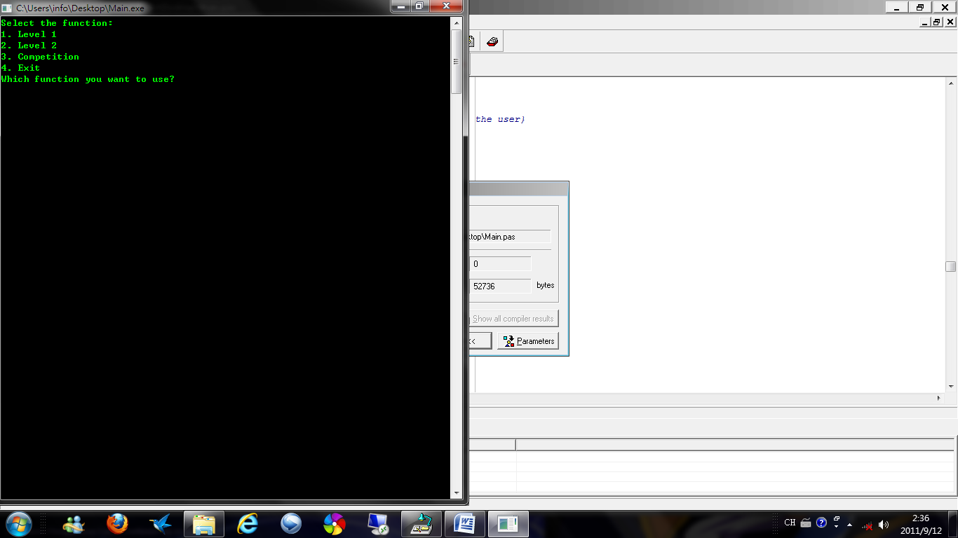

1. **T**o ‘Level 1’, you can see a word missing a letter, and you have to find out the missing letter

**(Higher level have more missing letter, such as ‘Level 2’ have 2 missing letter)**

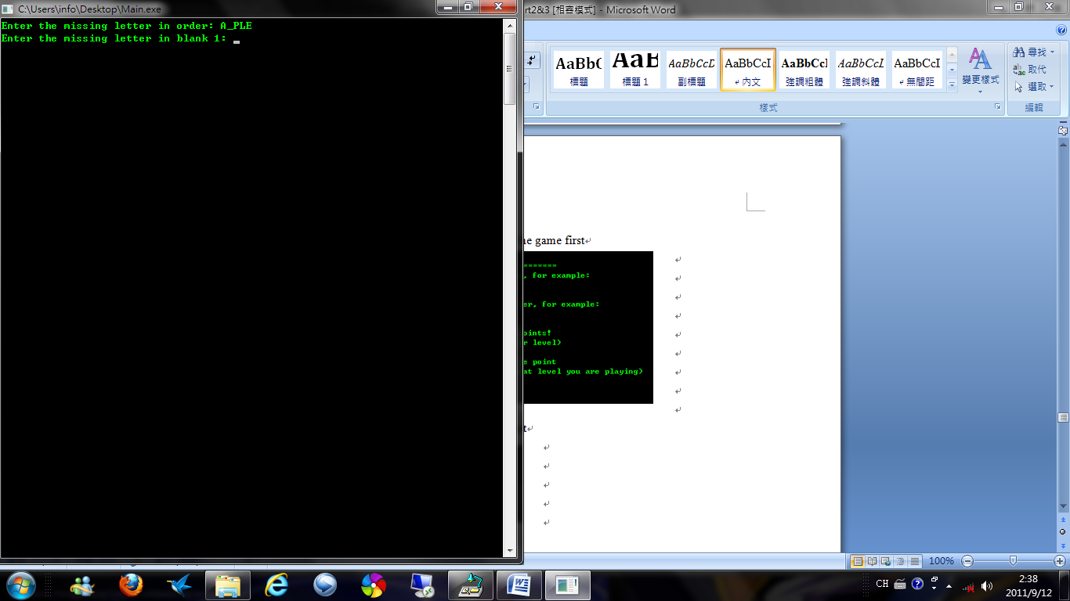

**I**f the answer is correct, you will gain point(s)

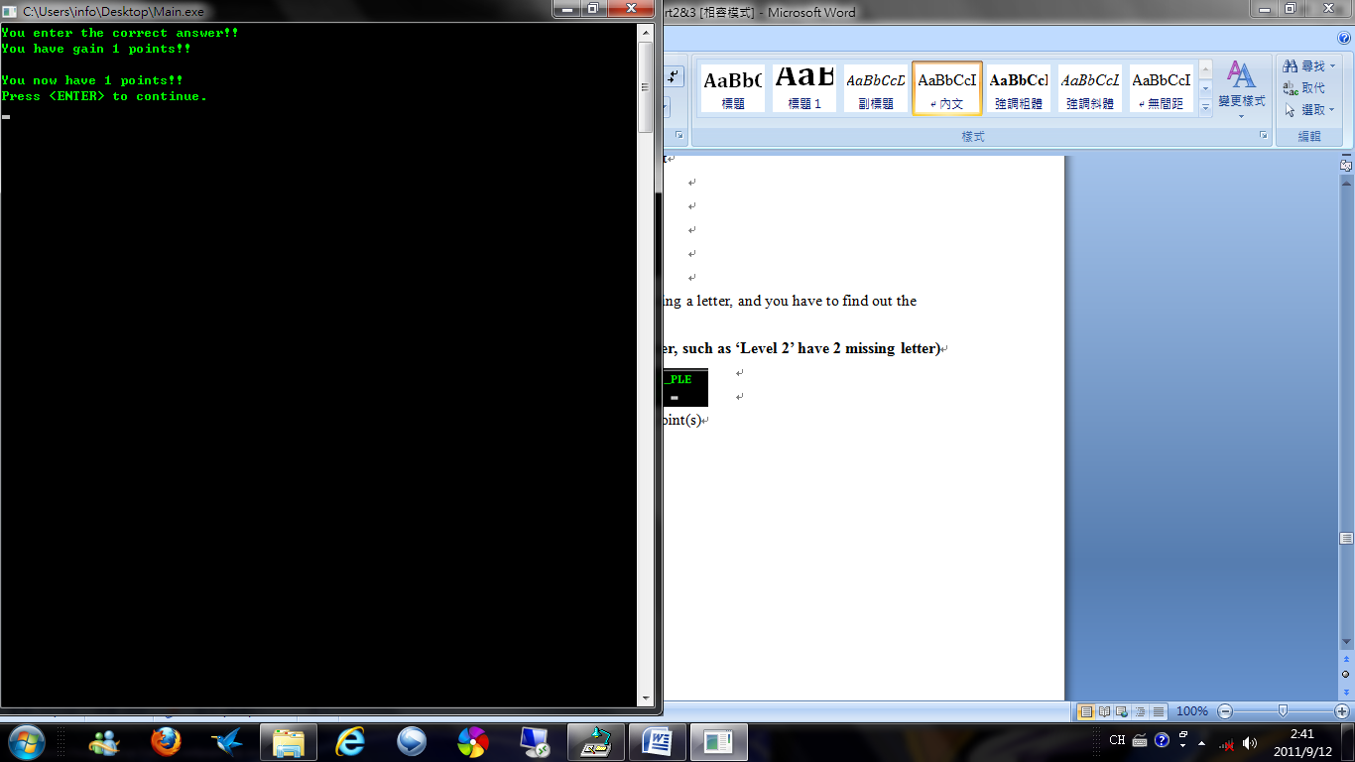

**I**f not, you may loss point(s) **(When your point is zero, you will not loss points)**

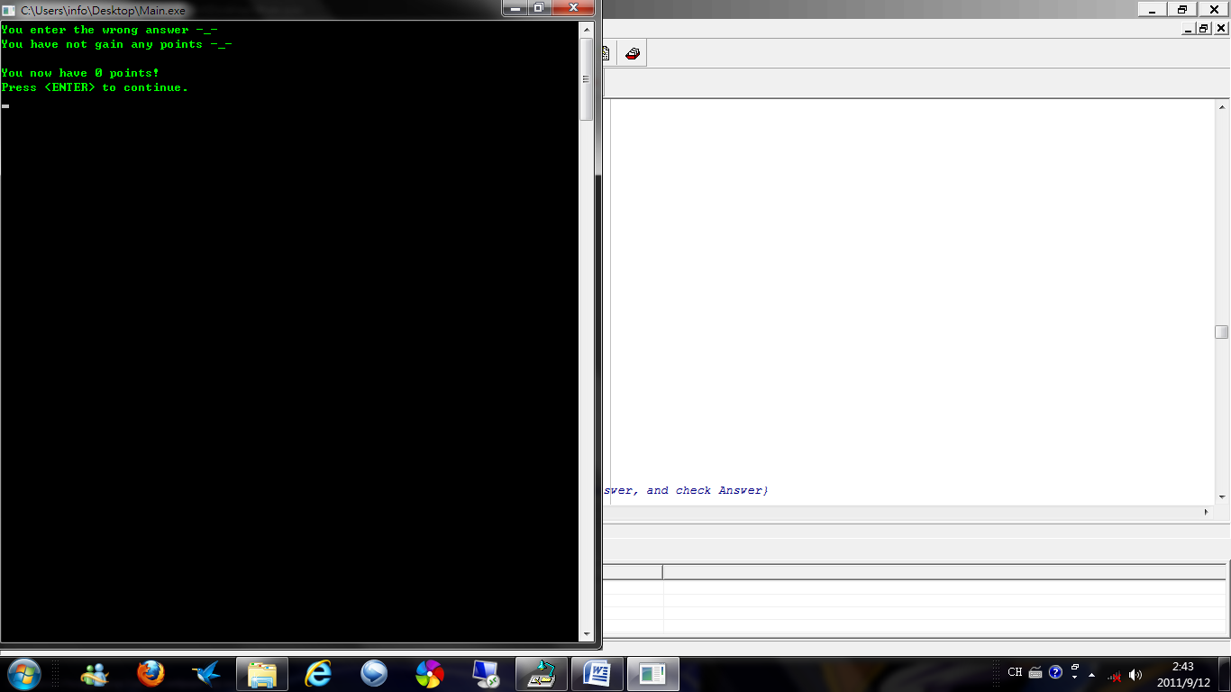

**T**hen, ask you try again or not, press ‘Y’ back to Step 11, press ‘N’ back to Step 10

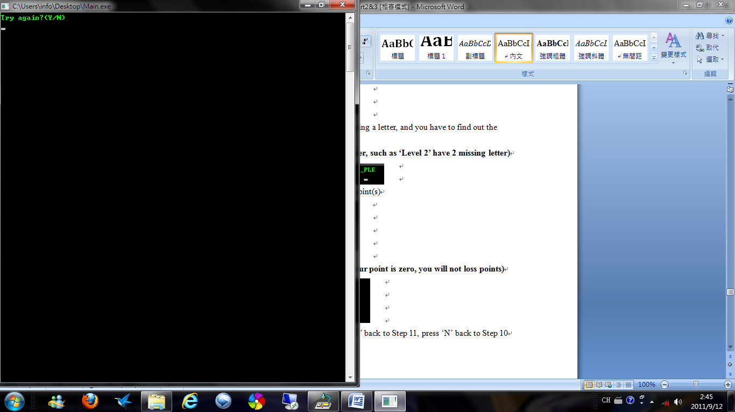

**12.** **T**o ‘Competition’, you will have a fight with computer ‘Mary’

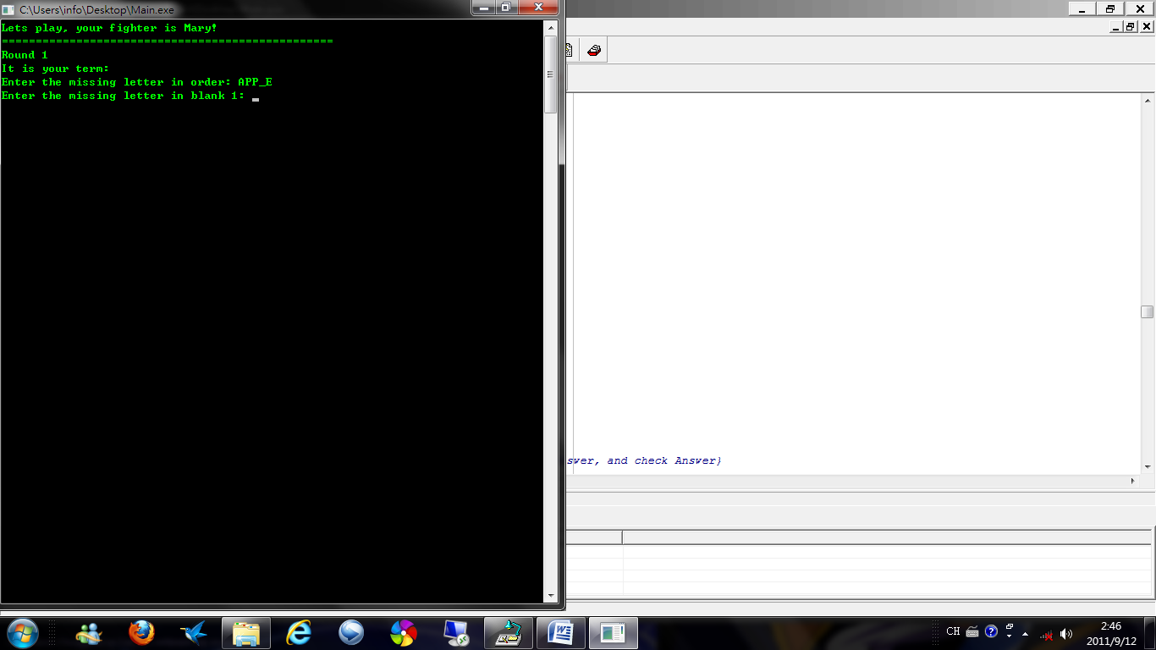

**A**nd other was just same as choosing level expect you can choose the round you play in the beginning

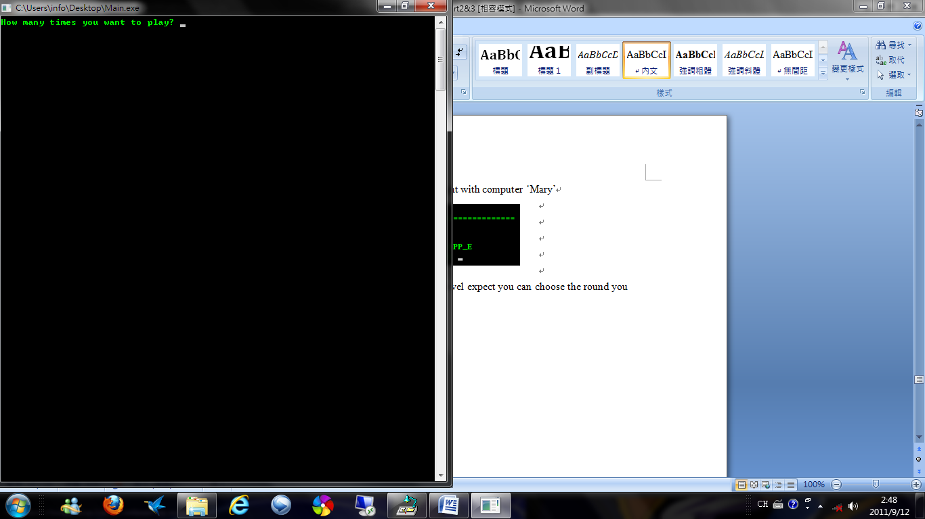

**A**fter the round, it will calculate the points you get in this round

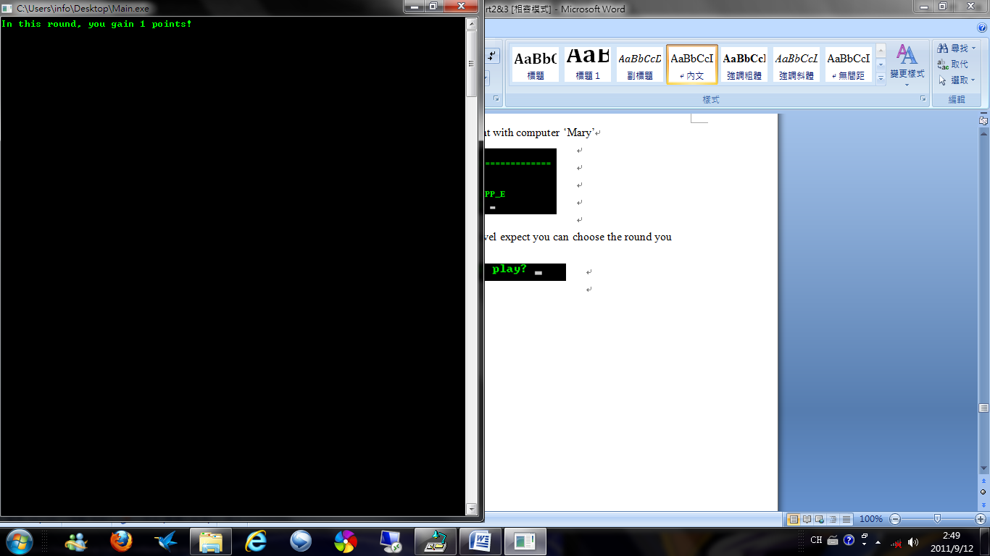

**A**lso Mary’s

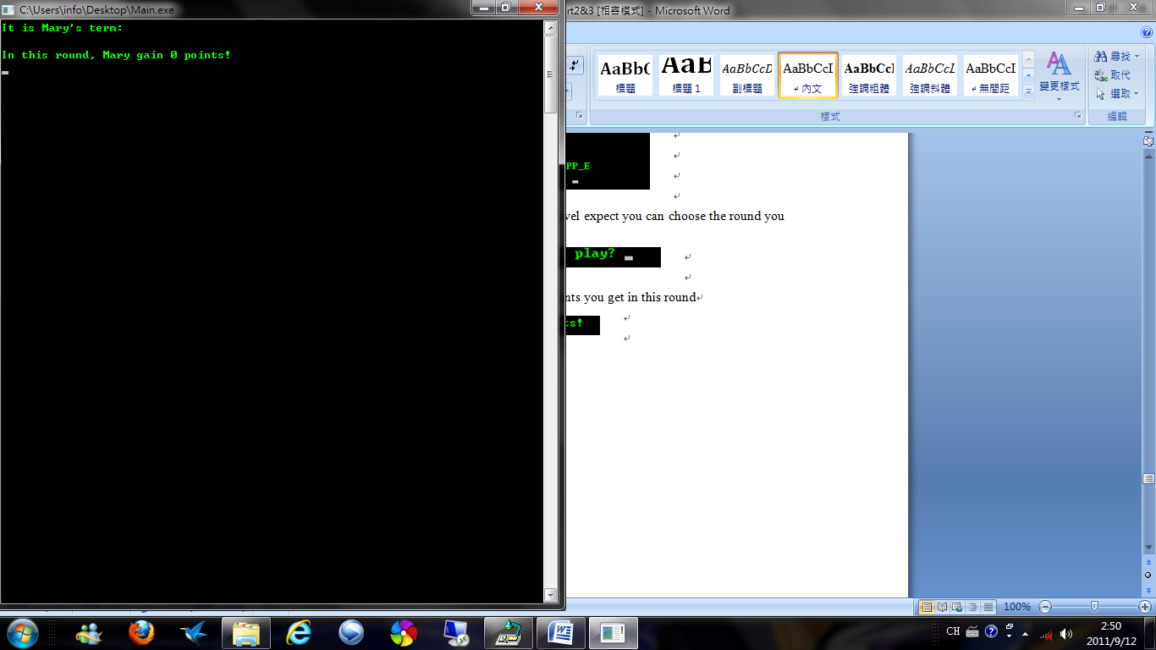

After that, by comparing the points you get in rounds with Mary’s, to decide the champion. **(When you two got the same points, you will be the champion)**

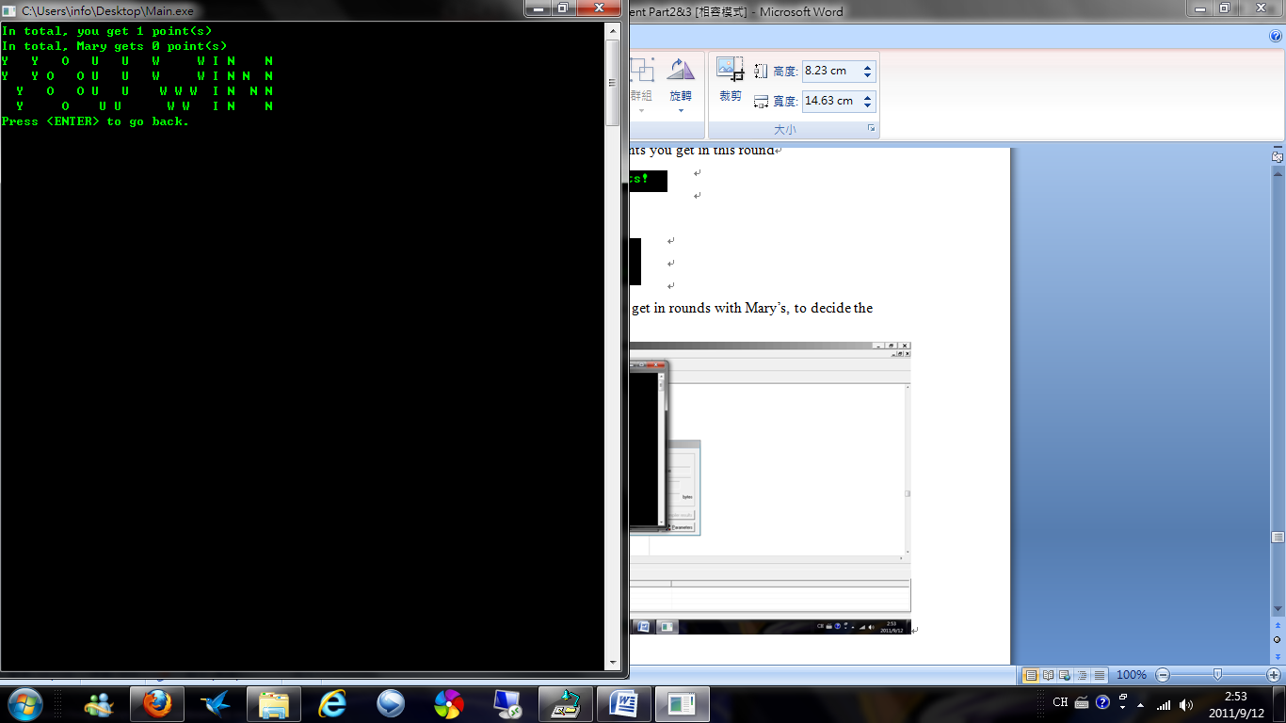

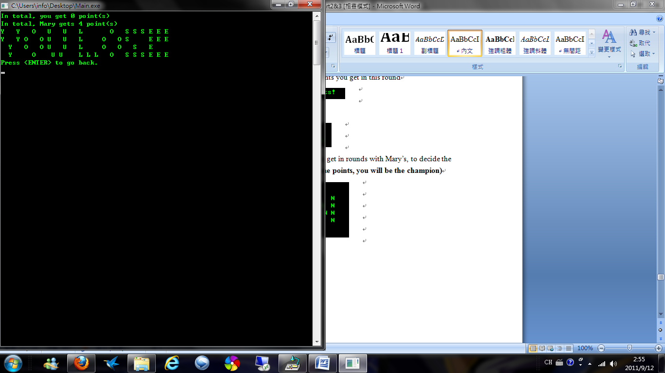

**Please do not press the button “X” on the top of the right hand side, otherwise all the things will loss. Please exit by the instruction of the program.**

**Variable lists**

Type arraystring=array[1..100] of string;

Data:arraystring;

LoginID:arraystring;

LoginPassword:arraystring;

Name:arraystring;

Sex:arraystring;

IDPoints:arrayinteger;

Points:arraystring;

FontColor:arraystring;

dictionary:arraystring;

save:integer;

choice:string;

count:integer;

IDNo:integer;

countdictionary:integer;

correct:boolean;

Again:string;

Letter:char;

Level:integer;

hold:string;

hold2:string;

num:integer;

Gamefile:text;

Profile:text;

x:integer;

y:integer;

limitx:integer;

limity:integer;

num2:integer;

middle:integer;

top:integer;

bottom:integer;

qword:string;

aword:string;

playerpoints:integer;

marypoints:integer;

randompoint:integer;

**Part 4 – Testing & Evaluation**

**Test Plan**

**T**o test the program, I decided to test the program by three types of error: syntax error, logic error and run time error.

**T**otest the syntax error, I will use complier to check whether there are syntax errors or not.

**T**o logic and run time error, I decided to test the input with different data: normal, abnormal and extreme. The different data can help to test the program in different way and can check whether there are logic or run time errors or not.

**F**or the normal data, I decided to input the data following the instruction, to test whether the program can run or not.

**F**or the abnormal data, I decided to input the data following the instruction but indifferent format, to test whether the program can understand the input or not.

**F**or the extreme data, I decided to input the data not following the instruction and the data should not be inputted in comment sense, to test whether the program can improper input.

**Testing for Syntax Errors**

**W**hile the program has to be executed, Pascal will auto check the code of the program for any syntax errors. If there are any syntax errors, the program will not be executed. Reversely, the program will be executed if there are no syntax errors.

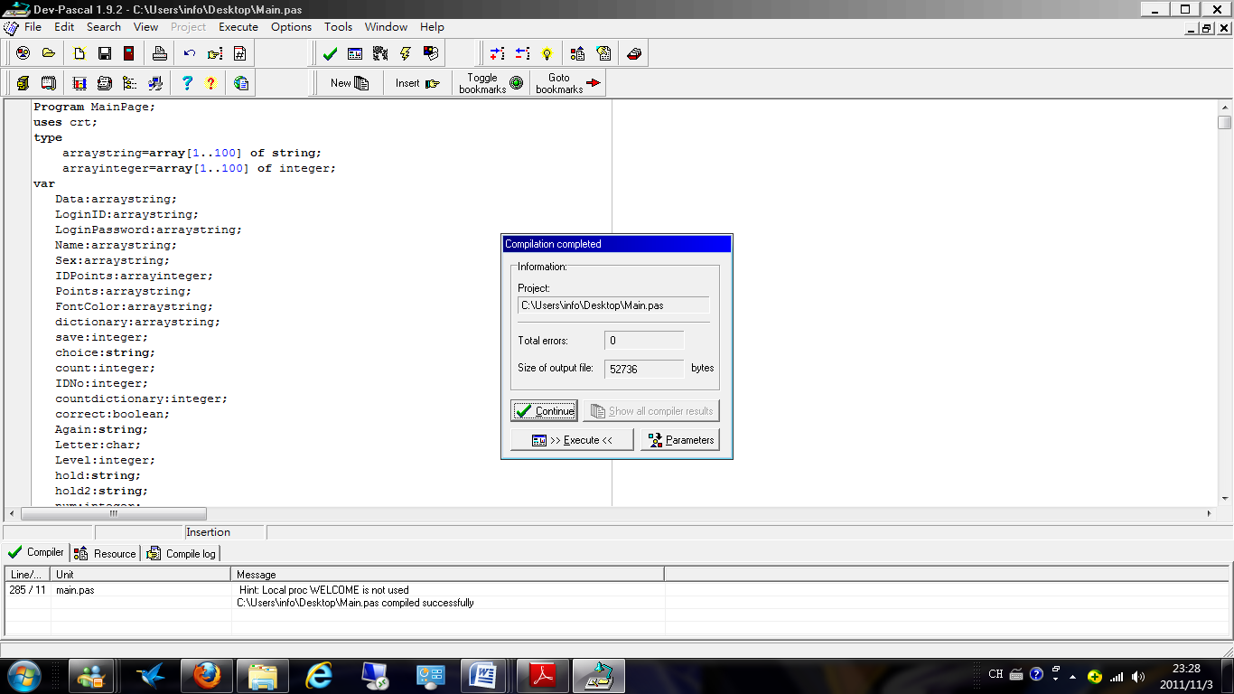Remarks:

Success

Evaluation:

The complier cannot check any errors in the program so the program does not have any syntax error.

**Testing for Logic and Run-Time Error**

**A**s test data is the most effective way to test whether there are logic or run-time error or not, I should use this way to have the test.

**I**n logic thinking, normal data should run properly, abnormal and extreme data should give warning; otherwise the program contains logic error.

**W**hatever using normal, abnormal or extreme data, when there are no run-time error; the program will not run the same things repeat until infinity.

**I** am going to test in the order of loading of the program and the main function from 1 to the end.

Testing step:

1. First page
2. Create account page
3. Login page
4. Main page
5. Game
6. Edit profile
7. Shop
8. Change the font color

**First Page**

**About This Page:**

This page asks user have signed or not

**Expected:**

Normal data:

-Go to login page or create account page

Abnormal data:

-Detected the error, give the warning and back to input again

Extreme data:

-Detected the error, give the warning and back to input again

**Test Data and Test Result:**

Normal data:

-Input ‘Y’, it went to login page

-Input ‘N’, it went to create account page

Abnormal data:

-Input ‘Yes’, it **detected error**, give the warning and back to input again

-Input ‘No’, it **detected error**, give the warning and back to input again

Extreme data:

-Input ‘go to login page’, it **detected error**, gave the warning and back to input again

-Input nothing, it **detected error**, give the warning and back to input again

**Remarks:**

Normal data:

-Success

Abnormal data:

-Success

Extreme data:

-Success

**Evaluation:**

All in all, this page can run whatever in what situation, which is normally and successfully. The first page can handle all type of data

**Create Account Page**

**About This Page:**

This page ask for ID, sex, name, password for create account, and back to first page

**Expected:**

Normal data:

- Create account and go to login page

Abnormal data:

-Detected the error, give the warning and back to input again

Extreme data:

-Detected the error, give the warning and back to input again

**Test Data and Test Result:**

Normal data:

-Input ‘Test’ for ID, it opened a new page for input password

-Input ‘123456’, it opened a new line for input password again

-Input ‘123456’, it opened a new page for input name

-Input ‘Test’ for name, it opened a new page for input sex

-Input ‘M’ for sex, it opened a new page for showing information

-Go to login page

Abnormal data:

-Input ‘Test’ (used) for ID, it **detected error**, give the warning and back to input ID until the ID did not used before

-Input ‘123456’, it opened a new page for input password again

-Input ‘1234567’, it **detected error**, give the warning and back to input password until both are the same

-Input ‘Test’ for name, it opened a new page for input sex

-Input ‘Male’ for sex, it **detected error**, give the warning and back to input sex until input is correct, then went to login page

Extreme data:

-Input nothing, it opened a new page for input password

-Input nothing, it opened a new page for input password again

-Input nothing, it opened a new page for input name

-Input nothing, it opened a new page for input sex

-Input nothing, it **detected error**, give the warning and back to input sex until input is correct, then went to login page

**Remarks:**

Normal data:

-Success

Abnormal data:

-Success

Extreme data:

-Failed (cannot detect any error except the input of sex)

**Evaluation:**

When I input nothing in this page, most of the time the program cannot detect the error, I should improve the program for detect the blank input as an error

**Correction:**

Check all the input whether it is blank or not. If it is, classify as an error and give warning

**Login Page**

**About This Page:**

This page asks user for ID and password for login

**Expected:**

Normal data:

-Go to main page

Abnormal data:

-Detected the error, give the warning and back to first page

Extreme data:

-Detected the error, give the warning and back to first page

**Test Data and Test Result:**

Normal data:

-Input ‘Test’ (created), it opened a new line for input password

-Input ‘123456’ (correct), it went to main page

Abnormal data:

-Input ‘test’ (it should be ‘Test’), it opened a new line for input password

-Input ‘1234567’ (should be ‘123456’), it **detected error**, gave the warning and back to first page

Extreme data:

-Input nothing, it opened a new line for input password

-Input nothing, it **detected error**, gave the warning and back to first page

**Remark:**

Normal data:

-Success

Abnormal data:

-Success

Extreme data:

-Success

**Evaluation:**

All in all, this page can run whatever in what situation, which is normally and successfully. The first page can handle all type of data

**Main Page**

**About This Page:**

This page asks user for using what function

**Expected:**

Normal data:

-Go to the function back

Abnormal data:

-Detected the error, give the warning and back to input again

Extreme data:

-Detected the error, give the warning and back to input again

**Test Data and Test Result:**

Normal data:

-Input ‘1’, it went to game page

-Input ‘8’, it went to exit page

Abnormal data:

-Input ‘Game’, it **detected error**, give the warning and back to input again

-Input ‘Exit’, it **detected error**, give the warning and back to input again

Extreme data:

-Input ‘9999’, it **detected error**, gave the warning and back to input again

-Input nothing, it **detected error**, give the warning and back to input again

**Remarks:**

Normal data:

-Success

Abnormal data:

-Success

Extreme data:

-Success

**Evaluation:**

All in all, this page can run whatever in what situation, which is normally and successfully. The first page can handle all type of data

**Game**

**About This Function:**

This function is for user to play the game

**Expected:**

Normal data:

-Check the answer is correct or not and give the result

Abnormal data:

- Check the answer is correct or not and give the result (incorrect)

Extreme data:

- Check the answer is correct or not and give the result (incorrect)

**Test Data and Test Result:**

Normal data:

-Input ‘a’ (answer is ‘a’), it gave the result

-Input ‘A’ (answer is ‘a’), it gave the result

Abnormal data:

-Input ‘apple’ (answer is ‘a’), it gave the result

-Input ‘APPLE’ (answer is ‘a’), it gave the result

Extreme data:

-Input ‘909180’, it gave the result

-Input nothing, it gave the result

**Remarks:**

Normal data:

-Success

Abnormal data:

- Success

Extreme data:

- Success

**Evaluation:**

All in all, this page can run whatever in what situation, which is normally and successfully. The first page can handle all type of data

**Edit Profile**

**About This Function:**

This function is for user to edit their information

**Expected:**

Normal data:

- Edit the information and back to choose edit page

Abnormal data:

-Detected the error, give the warning and back to input again

Extreme data:

-Detected the error, give the warning and back to input again

**Test Data and Test Result:**

Normal data:

-Input ‘1234567’ (edit password, original password is ‘123456’), it edited the information and back to choose edit page

Abnormal data:

-Input ‘123456’ (edit password, original password is ‘123456’), it detect the error, give the warning and back to input again

Extreme data:

-Input nothing (edit password, original password is ‘123456’), it edited the information and back to choose edit page

**Remarks:**

Normal data:

-Success

Abnormal data:

- Success

Extreme data:

- Failed

**Evaluation:**

-Same as the failed before. When I input nothing, the program cannot detect the error, I should improve the program for detect the blank input as an error

**Correction:**

Check all the input whether it is blank or not. If it is, classify as an error and give warning

**Shop**

**About This Function:**

This function is for user to buy with spending their points

**Expected:**

Normal data:

- Checked the user have enough points or not, if yes then send to the user’s house, if not then give the warning and back to input again

Abnormal data:

-Detected the error, give the warning and back to input again

Extreme data:

-Detected the error, give the warning and back to input again

**Test Data and Test Result:**

Normal data:

-Input ‘1’ (buying Wellcome coupon, enough points), it deducted the points

-Input ‘1’ (buying Wellcome coupon, not enough points), it gave the warning and back to input again

Abnormal data:

-Input ‘Wellcome coupon’ (buying Wellcome coupon, enough points), it gave the warning and back to input again

-Input ‘Wellcome coupon’ (buying Wellcome coupon, not enough points), it gave the warning and back to input again

Extreme data:

-Input nothing (enough points), it gave the warning and back to input again

-Input nothing (not enough points), it gave the warning and back to input again

**Remarks:**

Normal data:

-Success

Abnormal data:

- Success

Extreme data:

- Success

**Evaluation:**

All in all, this page can run whatever in what situation, which is normally and successfully. The first page can handle all type of data

**Change the font color**

**About This Page:**

This function is for user to change the font color

**Expected:**

Normal data:

-Save the change and change the font color

Abnormal data:

-Detected the error, give the warning and back to input again

Extreme data:

-Detected the error, give the warning and back to input again

**Test Data and Test Result:**

Normal data:

-Input ‘1’ (changing green color), it changed the font color into green

-Input ‘7’ (changing white color), it changed the font color into white

Abnormal data:

-Input ‘green’ (changing green color), it **detected error**, give the warning and back to input again

-Input ‘WHITE’ (changing white color), it **detected error**, give the warning and back to input again

Extreme data:

-Input ‘9999’, it **detected error**, gave the warning and back to input again

-Input nothing, it **detected error**, give the warning and back to input again

**Remarks:**

Normal data:

-Success

Abnormal data:

-Success

Extreme data:

-Success

**Part 5 – Conclusion & Discussion**

**Strengths of my program**

* The program can fulfill the requirement. It can provide an information system for children to **play English vocabulary games**, which **improve their English** vocabulary.
* The start of the program is an animation, which not just opens and sees the login page; it makes the program look **pretty** and **professional**.
* Most of the time the program is **input less**, for example only need to input one number or one English character to select the choices, it is more **user-friendly** and **easier to use**.
* The program contains **login system**, everyone can have their own account and they can save their personal information, which is user-friendlier.
* The game inside the program is using **checkpoint style**, user can play one time and give up to do other thing but not trapped in the game, which is user-friendlier.
* The game can get the points and it can **rank** with other people. Also the points can use in **shopping** because the program contains shop and user can buy things by using their points.
* The game contains a **competition mode**, the user no need to play single mode to be so lonely, it can **attract** user’s **interest**.
* The program can have the **font color change**, the user can change the font color as they want, and it is user-friendlier because user can change the color as what they feel.
* The variable of the program is easier understand because the variable were named as their function except the variable user for counting, it help the programmer **easier to improve the program**.
* The procedure have been used for many times while coding, I make the procedure into different but useful, the procedure can separate with his own use and merge them together with another use, which make the **algorithm become efficient**.

**Weakness of my program**

* By the effect of technique, the program **cannot link to Internet** and no Internet competition and no ranking all over the world.
* A dictionary contains too many words, I do not have enough time to search all the words with their meanings and set as a function on the program so it **did not contain dictionary**.
* As the program target user is kindergarten student, they do not have enough knowledge and not learn so many English, so the game only contains **one vocabulary.**
* Some times when the user input nothing, the program can still run without error warning, it is a **small bug** in the program.
* The program need user create a set of folder and file to the C driver first, otherwise the program cannot run, it makes **user-unfriendly**.
* The variable of the program become easier to understand but more than it should be, I created too many variables. Although all the variables have their own meaning, it is **hard for the programmer to correct the program**.
* The animation at the start needs to wait for 3s and it **wastes the user’s time.**
* **Only one game** in the program, which may not suitable for every users

**Evaluation of Strengths and Weakness**

**O**verall speaking, the program is **suitable for user to learn English** and **fulfill the purpose** of the English language-learning center. The start of the program having an **animation** and it makes the program **look beautiful** and **professional**. Also the most of the time the program is **user-friendly**, for example, the program only need the user **input a letter** to select the choice, having the **login system** so the user can have their own account and **no mixed up** with others, using the **check point style** so the user can **quit the game** **whenever they want**, and the user can **change the font color** as they like. Moreover, the user can **get points** from playing the game so they can have **compare with other** players and use the points to **buy things**. Apart from that, the game has the **competition mode** so user can play with the computer and have more fun. In addiction, there are lots of **meaningful**, **easy-understanding variable** and **using procedures** to write the program, so the program can **be** **improved easily**.

**A**lthough the program looks so good, it still having some problem, some extreme input (most of the time is input nothing) can be run as well, this is one of the **small bugs** remaining in the program. Also the program **cannot connect to the Internet**, so the user can play with the people who is using the same computer and cannot fulfill the planned did before. Moreover, the problem has **no dictionary** and **only containing one vocabulary**, it cannot fulfill the planned as well and cannot improve the user’s English so well. Apart from that, the program still having the part of **user-unfriendly**, the started animation need to **wait for 3s**, **only one game** for the user to play, and **need to create the a set of folder and file** before running the program. In addiction, because of the easy-understand and meaningful variable, it makes **too many** **variables** and hard for **the programmer to correct the program**

**Further developments that can be made**

* Provide the internet competition and world ranking to make the user have more interest on playing the game
* Build up a dictionary, which includes very single words with their meaning to help the user look for the word and learn.
* Add more easy vocabulary which can make the game become harder and help the user learn more vocabulary
* Auto create the needed folders and files to be more user-friendly
* Add Chinese input to make the ID have more change
* Add the skip while playing the animation to be more user-friendly
* Add the change of background color to make the program have more different style
* Add image in the program to make it beautiful
* Tell the correct answer while the user answer the wrong answer in the game to let the user learn from their mistake
* Add the select of system language to make it be user-friendly for other countries’ users
* Change the program into GUI (Graphical User Interface)
* Be a open source software
* Give it to the school freely
* Upload into different platform

**Evaluation of Further developments**

**O**verall speaking, the program is not completed yet; it can still be improved. The game can improve in Internet, to **link up with other player** and have more fun. Also the dictionary should contain **more vocabulary** to make the game become **more changes** with the dictionary to **explain the meaning** of that word, it can help the user know the correct answer and **learn from their mistake**. Moreover, the game can be **user-friendlier**, for example add the **skip button** for the animation, **skip the step** of creating a folder and file, and add the **select of system language**. Apart from that, the game can be **more colorful**; it can **add some images** or make it become **GUI**. In addiction, it can add **Chinese input** to make the ID and password have more change.

**B**eside those technical things, the program can **open the source**, to let more interested user to have **more improvement**, it can make the program be more prefect and **suitable for more people**. Also the program can be **free of charge** and give it to the school, to make the program become **more popular**. Moreover, the program can be **uploaded into different platform**, for example the **forum**, **app store**, and **android market**. It can make the program become **popular** and more people can use it.

**Reflection on my learning process**

**B**efore the project, I thought I learnt all the skills by writing a program and all the knowledge on ICT and Pascal. Nevertheless, I was wrong, totally wrong. I realized I **know is very little**, using my knowledge I still facing lots of challenges.

**D**oing the project is a tough job; I feel the **time is not enough** for me to complete the program, to make it perfect. I know is too little that I have search more information about programming, luckily the Internet is very helpful, most of the information can be searched on the Internet. But **lucky not always**, I had accident before the hand-in day, it delayed the work of the project, I had to use my injured hand to code. This makes me know **finish things as soon as possible** is so important.

**A**part from the time management, I learn some new **programming skills** and **algorithms design skills**. Those skills did not study from the teacher but by myself, I learn study is not trapped in books or teach by teacher but by our self, **self-study is so important**.

**B**esides study, I learn the **problem solving skills**, the project makes me know challenge always happened, I had faced lots of problems during programming, I did not solve all of them but most of them, I did not have enough time and I have to decide the solution of the problems as soon as possible, it **train my brain** be more sensible for solving a problem.

**A**ll in all, the project is though, but I think it is meaningful, we can learn from it and I am sure, I really want to have such project again.